Instruction

You could run the program by the following method；

1. Open the CS 589 Project.exe, you will see

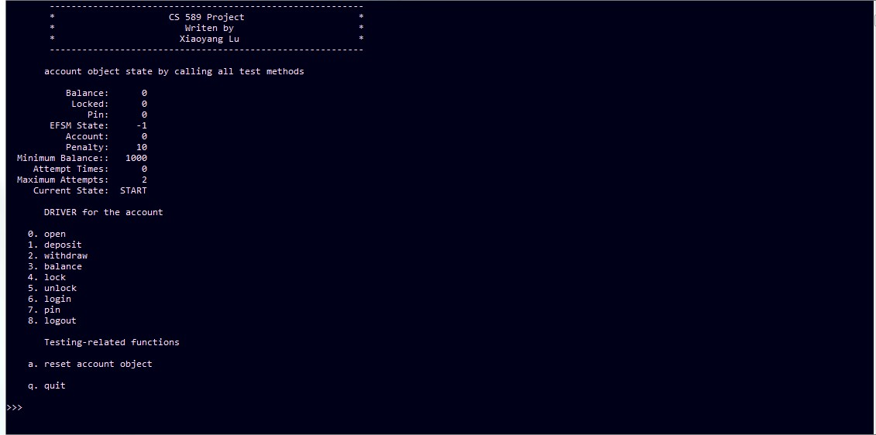

1. Choose the operation you want, such as open operation, and input the related value, you will see

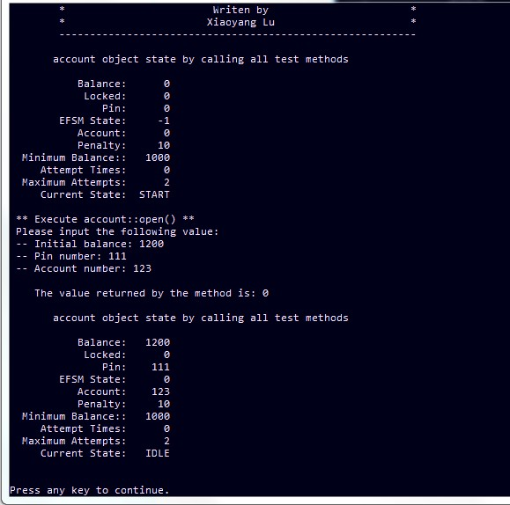

1. You could see the details of the program in current state, other operation executions are similar.
2. You can press any key to continue and press ESC to quit the current state.
3. When you want to reset a new account, after you press ESC, you can press function a to reset a new account, as following:

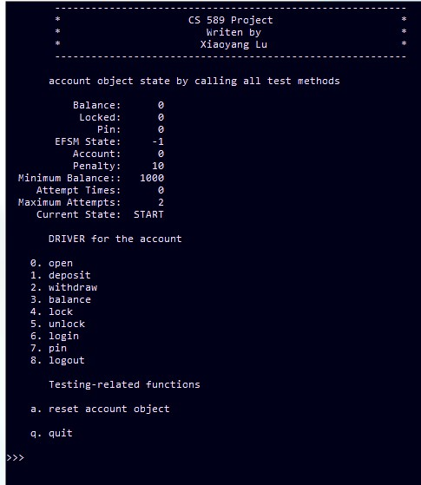

1. When you finish the program, you can press q to quit the whole program.